iOS Smart Mobile

**Research Journal**

By Anders & Bart

vandret linje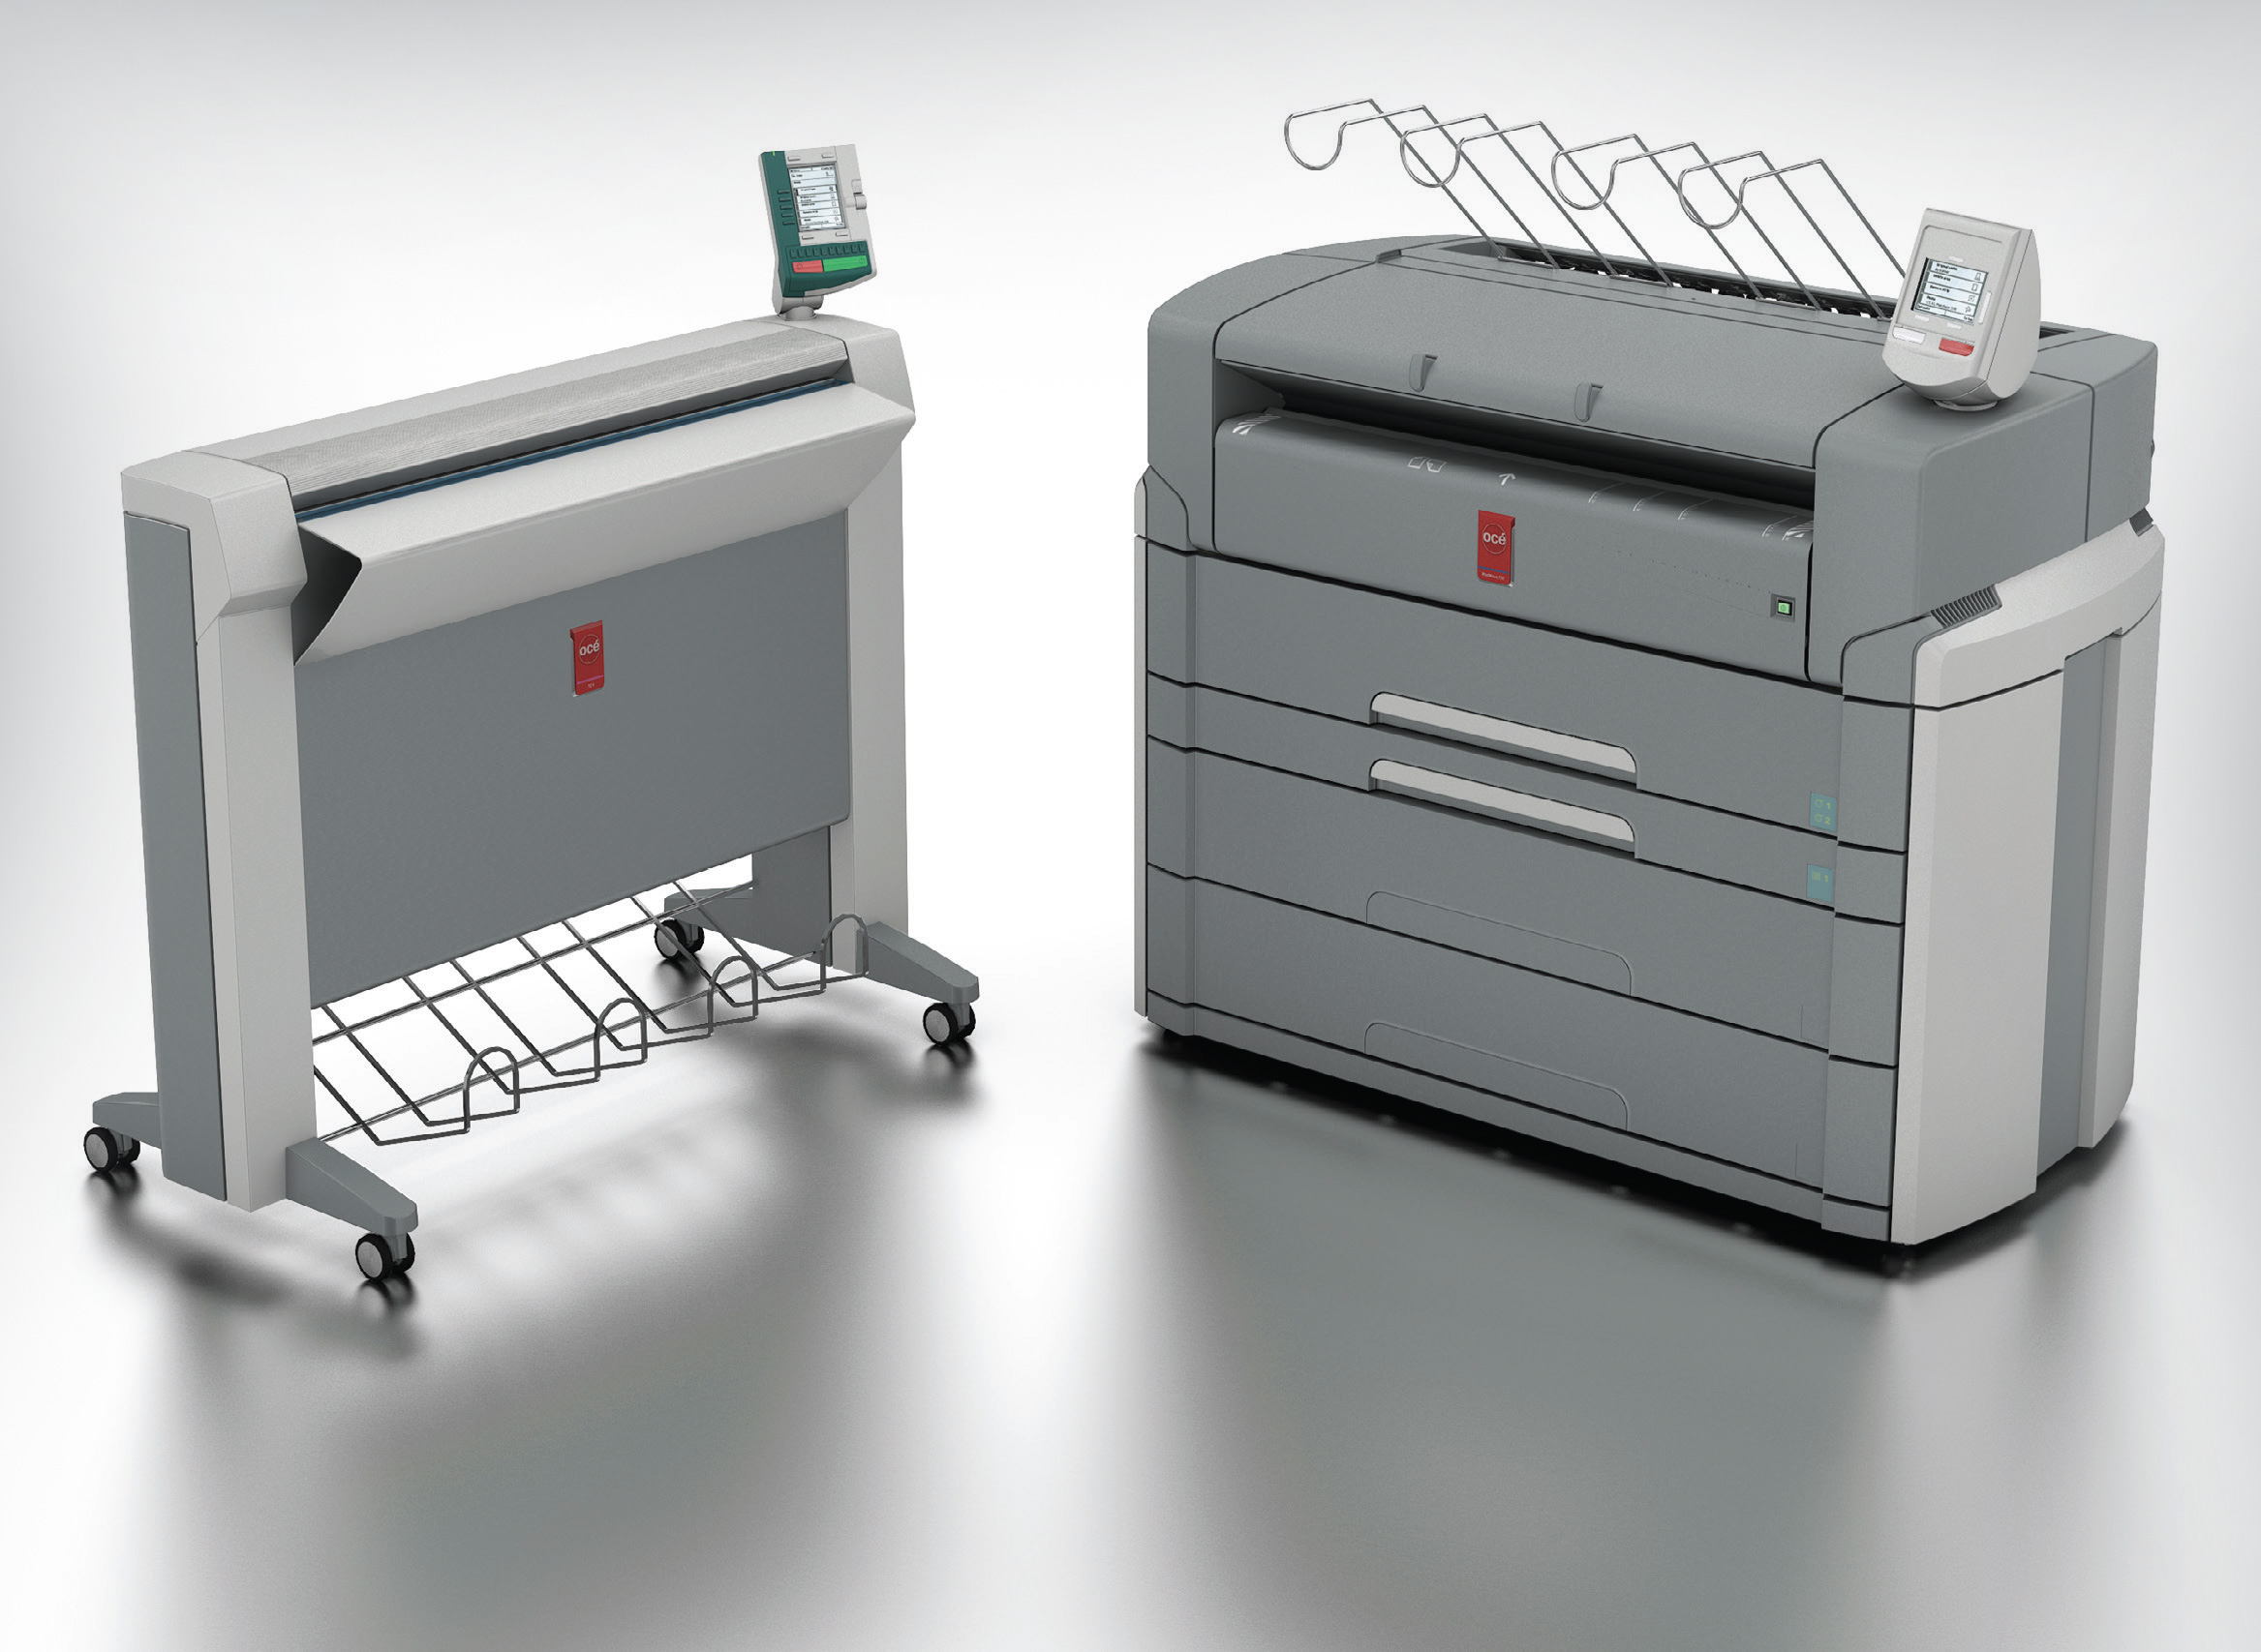

# Introduction

This document contains Anders and Bart’s research for the project. The research consist of two tests, that has an ethical aspect, and a research which we did based on feedback we received from the company. The first test’s purpose is to find out which kind of light is the most noticeable. The second test is to back some research up we did regarding colors and how we perceive them. The research paper is about Oce’s printers that were in the initial presentation. The other research group in our project group did more literature research, we focussed on the practical research although we still did a bit of literature research ourselves.

TABLE OF CONTENT

**HUE TEST** **4**

INTRODUCTION 5

RESEARCH 5

RESEARCH QUESTIONS 5

HYPOTHESIS 6

EQUIPMENT 6

PROCEDURE 6

DATA 7

TEST PERSON 7

BULB POSITION 7

NOTICED WHITE LIGHT 7

NOTICED FLASHING 7

NOTICED FADING 7

RESULTS 7

CONCLUSION 8

RECOMMENDATION 8

SOURCES 9

**COLOR TEST** **10**

INTRODUCTION 11

RESEARCH 11

COLORS COMMONLY USED TO IDENTIFY SEVERAL EMOTIONS 11

RESEARCH QUESTIONS 12

HYPOTHESIS 12

EQUIPMENT 12

PROCEDURE 12

DATA RESULTS 13

TESTPERSON 1 13

TESTPERSON 2 13

TESTPERSON 3 14

TESTPERSON 4 14

CONCLUSION 15

RECOMMENDATION 15

SOURCES 16

**OCE PRINTER RESEARCH** **17**

OVERVIEW 18

RESEARCH GOALS 18

RESEARCH QUESTIONS 18

RESULTS 19

PRINTER BASIC INFORMATION 19

PRINTER RUNTIME CALCULATED 20

CONCLUSION 22

RECOMMENDATION 22

SOURCES 23

# HUE TEST

*Which kind of light is most noticeable?*

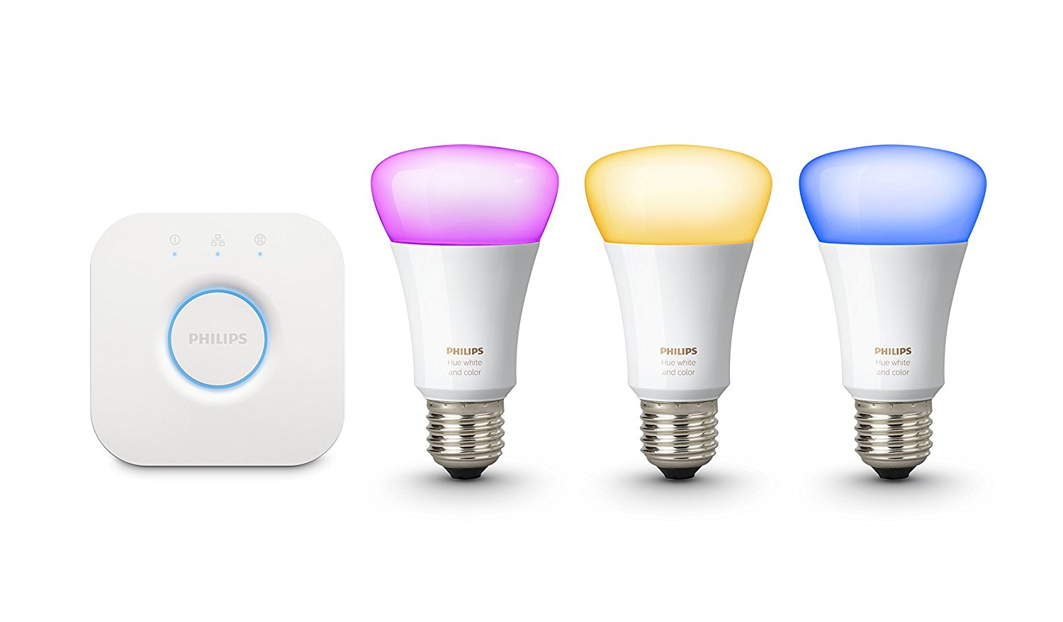

25-5-2018

Anders and Bart

## INTRODUCTION

After the feedback from the client and the lecturers, we planned this test to make our concept stronger. The unique selling point of our concept, the fading light, falls and stands on the fact that is noticed by the worker in the factory. We want to know, which kind of light is the most noticeable; critical errors should have an alert that is noticeable.

Therefore, we want to test if people notice a light changing color. We have also included a flashing light, to test if that is easier to notice.

Before we started the test, we have done some research about the human field of view. Based on the outcome of this research, we composed our hypothesis.

## 

## RESEARCH

Field of view: “The approximate field of view of an individual human eye is 95° away from the nose, 75° downward, 60° toward the nose, and 60° upward, allowing humans to have an almost 180-degree forward-facing horizontal field of view.”[1]

## RESEARCH QUESTIONS

Does the test person notice the different light settings?

Which kind of light is most noticeable in a wide angle?

## HYPOTHESIS

If the light is placed out of the field of view, the light will not be noticed by the test person.

## 

## EQUIPMENT

1. Philips Hue bulb, Bridge and Router.
2. Computer with simple questions and 2 minute timer.
3. Camera to film the test.

## PROCEDURE

1. Test person enters the room, sits down at the table. The tester explains the test and starts the timer. The light is still off at this point. Test person does not know about the light. Test person thinks, he/she should answer some questions for two minutes.
2. The test person answers the questions, and tester 1 turns on the light. Tester 2 checks if the test person notices the light turning on.
3. Tester 1 blinks the light and tester 2 again, checks if the test person notices.
4. Tester 1 Fades the light from green to red. Tester 2 checks if the test person notices any change.

## 

## 

## 

## DATA

|  |  |  |  |  |
| --- | --- | --- | --- | --- |
| TEST PERSON | BULB POSITION | NOTICED WHITE LIGHT | NOTICED FLASHING | NOTICED FADING |
| PERSON 1 | Far right |  |  |  |
| PERSON 2 | Far right |  |  |  |
| PERSON 3 | Closer right |  |  |  |
| PERSON 4 | Almost in front of the computer |  |  |  |

## 

## RESULTS

The first test person didn’t noticed the light at all. We wanted to try with another person with the light in the same spot. The second test person noticed the lights flashing, but didn’t notice the white or fading light. Therefore, we decided to move the light a little bit closer to the computer, which means the light would be a little bit closer to the central horizontal field of view.

The third test person noticed every kind of light. We moved the light even closer to the computer, and the fourth test person noticed every kind of light but the fading. The last test person was used as a ‘benchmark’ - we we’re sure that at least some of the lights were being noticed.

## 

## 

## CONCLUSION

The outcome of the test is backed by the research we did beforehand. The further away the light is placed, the less the light gets noticed. The flashing light is more noticeable at a wide angle than a change of color.

## 

## RECOMMENDATION

Our concept can be improved with the outcome of the test. When a critical situation needs quick response, the light indicating the situation starts flashing. This way the chance of noticing is increased.

## 

## SOURCES

1. Source: <http://www.cdcc.usp.br/cda/cursos/2015/licenciatura-2015-08-21-telescopios/Human%20eye.pdf>
2. Video: <https://youtu.be/5H67S4Pyuq4>

## horizontale lijn

# COLOR TEST

*Colors associated with a emotions*



8-6-2018

Anders and Bart

## INTRODUCTION

After the first test, where we tested the attention of the people, we need another test before we can fully integrate the Philips Hue lights into our project. We want to verify the research about the emotion of color. To do this, we will show the test person different colors, and ask him/her to assign the colors to one of the following category: Normal, warning and error. When the person doubts, we can ask some questions about the emotion they are feeling when they see the color.

The hypothesis of this test is based on the test outcome we expect, after looking at the results of the research.

## 

## RESEARCH

The research we have done so far states that certain colors is associated with different emotions/actions. The perception of certain colors is documented and corporations use colors to manipulate with their customers. For example: In food stores, bread is normally sold in packaging decorated or tinted with golden or brown tones to promote the idea of home baked and oven freshness.

|  |  |
| --- | --- |
| COLORS COMMONLY USED TO IDENTIFY SEVERAL EMOTIONS | |
| BLACK | MOURNFUL, COLD |
| BLUE | SHYNESS, CALMNESS, SADNESS |
| GREEN | HEALTH, RELIABILITY, SAFETY |
| GREY | EMOTIONLESS, DEPRESSION |
| PINK | LOVE, EMBARRASSED, CHERRY |
| RED | ANGER, EMBARRASSMENT, PASSION, LUST |
| WHITE | SHOCKED, SCARED, SICK, MOURNFUL |
| YELLOW | HAPPINESS, CAUTION, COWARDICE |

## RESEARCH QUESTIONS

In which category are the colors we are going to show to the test person?

Which emotions are evoked when seeing the colors?

## 

## HYPOTHESIS

The outcome of this test will confirm the research done already.

## 

## EQUIPMENT

1. Philips Hue bulb, Bridge and Router.
2. Computer to document answers.

## 

## PROCEDURE

1. Test person enter the room and, sits down at the table. Testers will explain the test to the test person.
2. Tester 1 will show a color on the philips hue.
3. Test person will determine which kind of alert/event (error, normal/all good, warning) he/she thinks of.
4. Tester 2 will document test persons answer.
5. This process will loop until test person have been shown all colors scheduled.

## DATA RESULTS

|  |  |  |  |  |
| --- | --- | --- | --- | --- |
| TESTPERSON 1 | | | | |
| COLOR | OK | WARNING | ERROR | COMMENT |
| RED |  |  |  |  |
| ORANGE |  |  |  |  |
| YELLOW |  |  |  | IS NOT NOTICEABLE ENOUGH |
| GREEN |  |  |  | NOT REALLY GREEN, A BIT BLEND |

|  |  |  |  |  |
| --- | --- | --- | --- | --- |
| TESTPERSON 2 | | | | |
| COLOR | OK | WARNING | ERROR | COMMENT |
| RED |  |  |  | SOFT COLOR, MORE LOOKING LIKE ORANGE |
| ORANGE |  |  |  | SHOULD BE MORE ORANGE TO BE A WARNING |
| YELLOW |  |  |  |  |
| GREEN |  |  |  |  |

|  |  |  |  |  |
| --- | --- | --- | --- | --- |
| TESTPERSON 3 | | | | |
| COLOR | OK | WARNING | ERROR | COMMENT |
| RED |  |  |  |  |
| ORANGE |  |  |  | NOT AS STRIKING AS RED |
| YELLOW |  |  |  | MILDER THAN ORANGE, LESS URGENT |
| GREEN |  |  |  |  |

|  |  |  |  |  |
| --- | --- | --- | --- | --- |
| TESTPERSON 4 | | | | |
| COLOR | OK | WARNING | ERROR | COMMENT |
| RED |  |  |  |  |
| ORANGE |  |  |  | SMALL ERROR |
| YELLOW |  |  |  |  |
| GREEN |  |  |  |  |

# 

## 

## CONCLUSION

The test results are very expected. The red color is placed in the error category every time, orange is mostly seen as a warning. Yellow is always placed in the warning category. Green is generally known as the color for OK-status.

These results are fully backed by the research done by the group.

## 

## RECOMMENDATION

Since the test confirmed our research, we will make use of the colors, as mentioned in the conclusion, in our prototype.

The colors the bulb produces can be too vague. It can be difficult to distinguish between the different colors, because the bulbs doesn’t show the colors intensively enough. Canon Ocè should consider using another solution.

## 

## SOURCES

1. <https://docs.google.com/document/d/1PW6n5cJ96T1prCvi5pzkLGTmK-nL90JEekFjHhn23tA/edit#> - Eye Section

## horizontale lijn

# OCE PRINTER RESEARCH

*A research to make it easier for the operator*



14-6-2018

Anders and Bart

## OVERVIEW

In this research we will examine some of the printers that Canon Oce sells. How much paper do they consume per hour? Is the printer using sheets or cut sheets? We need some answers to these questions to determine when the lights should start the fading. If the printer has a capacity of 10.000 sheets of paper, and it consumes approximately 2.500 per hour, we need to find out the specific percentage to signal the operator that it is time for a refill to prevent the printer to stop.

## 

## RESEARCH GOALS

To gain enough knowledge to determine at which percentage of capacity the light should start fading.

## 

## RESEARCH QUESTIONS

How much paper is consumed by Océ’s printers?

At what speed are the printers consuming paper?

# 

# 

## RESULTS

|  |  |  |  |
| --- | --- | --- | --- |
| PRINTER BASIC INFORMATION | | | |
| Printer | Type | Paper (media) Capacity | Paper Consumption |
| Colorwave 700 | Rolls | Six rolls with a length of 200 meters. 1200 meters in total | 247 m² per hour |
| Arizona 6170 XTS | Boards: plywood, panel or other architectural applications | N/A | 33 boards per hour |
| VarioPrint i300 | Cut sheet | 9200 sheets | 9.120 |
| VarioPrint 6330 Titan series | Cut sheet | 16.000 sheets | 2000 books per day |
| Colorstream 6000 Chroma | Rolls:  70 mm, 3”, 5” and 6” |  | 125.000 personalized magazines per day  324-1714 A4/min |
| ProStream 1000 | Rolls:  3”, 5” and 6” |  | 1076 A4 per minute |
| Colorado 1640 | 64” roll-to-roll large format printer with UVgel technology | 50 kg per roll, 1 input roll, 1 output roll. | 159 m2/h |

To get useful information out of this data, we need to calculate the media consumption per hour. Than we can determine the total runtime, which is associated with the amount of refills needed.

|  |  |  |  |
| --- | --- | --- | --- |
| PRINTER RUNTIME CALCULATED | | | |
| Printer | Media consumption per hour | Total runtime on full media load | Explanation |
| Colorwave 700 | 247 m² | Approximately 5 hour |  |
| Arizona 6170 XTS | 33 boards | N/A (no paper tray) |  |
| VarioPrint i300 | 9.120 | Approximately 1 hour |  |
| VarioPrint 6330 Titan series | 19.680 | Approximately 50 minutes | Assuming the paper is A4. |
| Colorstream 6000 Chroma | No information | No information |  |
| ProStream 1000 | 4.800 meters | No information |  |
| Colorado 1640 | 159 m2 | Approximately 1 hour 50 minutes | assuming 170 gram/m2 paper is used. |

We use three machines in our demo application. It will be implemented as followed:

Colorwave 700

Fade start time: 20 minutes before runout. 4%

Red light: 10 minutes before runout. 2%

Flashing: 5 minutes before runout. 1%

VarioPrint i300

Fade start time: 20 minutes before runout. 33%

Red light: 10 minutes before runout. 16%

Flashing: 5 minutes before runout. 8%

Colorado 1640

Fade start time: 20 minutes before runout. 18%

Red light: 10 minutes before runout. 9%

Flashing: 5 minutes before runout. 5%

## 

## CONCLUSION

The printers have different specifications meaning, that they do not have the same capacity and print speed. We have found some numbers and made some few assumptions eg. how much time it takes to refill the paper tray. The lights will not start fading at a static value.

## 

## RECOMMENDATION

With the knowledge we have gained from the research, we have decided, that the best solution would be to give the operator enough time to refill the paper. Our equations is based on that the lights should start fading when there is paper enough for 20 minutes. That means that each printer has a specific and individual percentage value where the light will start fading.

## 

## SOURCES

Printer: Colorwave 700

Sites:

<https://www.canon.co.uk/for_work/products/large_format_printers/technicalprint/colour/oce_colorwave_700/>

Videos:

<https://www.youtube.com/watch?v=_TshULmcdGk&t=125s>

Printer: Arizona 6170 XTS

Sites:

Videos:

<https://www.youtube.com/watch?v=6sEJfqrdbjg>

<https://www.youtube.com/watch?v=SCi8Ze5Cj9I&t=83s>

Printer: VarioPrint i300

Sites:

<https://www.canon-europe.com/business-printers-and-faxes/cut-sheet-colour-printers/varioprint-i300/specifications/>

Videos:

<https://www.youtube.com/watch?v=g2xa9ksY3N4>

Printer: VarioPrint 6330 Titan

Sites:

<https://www.canon.com.cy/business-printers-and-faxes/cut-sheet-black-and-white-printers/varioprint-6330-titan/specifications/>

Videos:

Printer: Colorstream 6000 Chroma

Sites:

<https://www.canon.co.uk/for_work/products/professional_print/digital_colour_production/colorstream_6000_chroma/specification.aspx>

Videos:

<https://www.youtube.com/watch?v=Gbn2dk15ImE>

Printer: ProStream 1000

Sites:

<https://csa.canon.com/online/portal/csa/csa/company/campaigns/oce-prostream-series>

Videos:

<https://www.youtube.com/watch?v=DObf3wxLzJ0>

Printer: Colorado 1640

Sites:

<https://www.canon-europe.com/business-printers-and-faxes/oce-colorado-1640/specifications/>

Videos:

# RESEARCH REFLECTION

**What we did good:** dividing the research tasks between the two research groups was a good start. The tests that we conducted was relevant and useful for the project. Also the research about the Océ printers was directly based on the feedback from the client the same day. We ended up not implement the results of the printer research in the prototype, because it wouldn’t make the prototype better. In a potential real implementation, the results of the research will be applied. We were effective when we found a useful test; it took us less than a day to design the test, conduct it and document it.

**What we can improve for next time:** we could have started a bit earlier brainstorming about research subjects for the project, that way we could have finished the research party a bit earlier. We could have had some deadlines, so that the research was a bit more planned. Regarding the tests we could have included a broader or more user groups; we used students from our class only, and it may have been a good idea to have used other as well such as teachers.

1. Check the links section for source.